**KABARAK UNIVERSITY**



**KABARAK UNIVERSITY**

**SCHOOL OF COMPUTER SCIENCE AND BIOINFORMATICS**

**DEPARTMENTY OF COMPUTER SCIENCE AND IT**

PROJECT PROPOSAL/RESEARCH PROJECT II

PROJECT PROPOSAL TITTLE**: AI ADVISORY BEAUTY COSMETIC SYSTEM**

**Github link:** **https://github.com/Mgloria91/AI-ADVISORY-BEAUTY-COSMETIC-SYSTEM**

**A Project Report Documentation Submitted in The Department of Computer Science and IT in partial fulfillment of the degree of Computer Science**.

**OISEBE MORAA GLORIA: BBIT/MG/2289/09/20**

**SUPERVISOR: MR. CLEOPHAS MOCHOGE**

**MAY-AUGUST 2024**

# **DECLARATION**

I certify that this is my own material and it cannot be asserted without my acknowledgement. It does not contain any other material that was submitted previously by our fellow students, except where there is a reference in the text stated. I also give consent, if accepted, to make the title and abstract available to outside organizations.

OISEBE MORAA GLORIA BBIT/MG/2289/09/20

Signature………………………. Date: ………………………

# **APPROVAL BY SUPERVISOR**

This research proposal has been submitted for review with my approval as the supervisor. I have reviewed this project and recommended it be accepted in partial fulfillment of the requirements for the degree in Bachelor of Business Information Technology.

**Mr. Cleophas Mochoge**

**Lecturer, School of Science Engineering and Technology**

**Kabarak University**

Signature………………………. Date: ………………………

# **ACKNOWLEDGEMENT**

I greatly appreciate the support from the entire School of Business and Economics, Kabarak University. My sincere gratitude to our supervisor Mr. Cleophas Mochoge who has shown commitment, patience and encouragement throughout the entire research project process. To our parents and guardians, we are very grateful for your financial and moral support.

Finally, we thank the Almighty God for bringing us this far.

# **ABSTRACT**

# Finding the right beauty products can be hard. Many people struggle to find cosmetics that suit their unique needs, leading to a lot of trial and error, wasted time, and money. Without personalized guidance, this often results in frustration and uncertainty, leaving users unhappy with their choices and unsure about which products truly enhance their natural beauty. This AI Advisory Beauty Cosmetic System aimed to change that by offering more than just skincare solutions. It sought to boost confidence and make skincare routines enjoyable. Acting as an educational companion, it evolved with users and celebrated each person’s unique skin. Like a supportive friend, it used innovative technology to make skincare routines exciting. Through advanced image analysis and personalized suggestions, it helped users start a transformative beauty journey, enabling them to unlock their potential and embrace their unique beauty with confidence. The system went beyond just suggesting products; it encouraged user interaction. Users could give feedback, share their experiences with recommended products, and help improve the system. It provided guidance like a knowledgeable skincare enthusiast, eager to help users reveal their inner glow. The AI Advisory Beauty Cosmetic System not only recommended products but also fostered confidence, self-expression, and empowerment in the beauty world. Users could explore their unique features and try new looks, knowing they had a reliable and knowledgeable ally guiding their cosmetic journey. In conclusion, research on the AI Advisory Beauty Cosmetic System introduced a groundbreaking solution to the ongoing challenge of selecting the perfect beauty products. By using image analysis and personalized suggestions, it helped individuals embark on a transformative journey, unlocking their true potential and embracing their individual beauty with confidence.

Contents

DECLARATION 2

APPROVAL BY SUPERVISOR 3

ACKNOWLEDGEMENT 4

ABSTRACT 5

CHAPTER ONE 10

INTRODUCTION 10

1.0 BACKGROUND OF THE STUDY 10

1.1 CURRENT SYSTEM 11

1.2 STATEMENT OF THE PROBLEM 11

1.3 PURPOSE OF THE STUDY 12

1.4 MAIN OBJECTIVE 12

1.5 SPECIFIC OBJECTIVES 12

1.6 RESEARCH QUESTIONS 13

1.7 PROPOSED SYSTEM 13

1.8 SYSTEM MODULES 13

1.9 JUSTIFICATION OF THE STUDY 14

1.10 FEASIBILITY STUDY 14

1.11 SCOPE AND LIMITATION OF THE STUDY 16

1.12 LIMITATIONS 16

CHAPTER TWO 17

LITERATURE REVIEW 17

2.0.1 AI AND PERSONALIZED BEAUTY RECOMMENDATION 18

2.0.2 USER EXPERIENCE AND ACCEPTANCE 18

2.0.3 CHALLENGES AND LIMITAIONS 18

2.0.4 FUTURE IMPLICATIONS 18

2.0.5 CONCLUSION 19

2.1 GENERAL OVERVIEW 19

2.1.1 EVOLUTION OF AI ADVISORY BEAUTY COSMETIC SYSTEM 19

2.1.2 ROLE OF TECHNOLOGY IN ENHANCING ACCURACY AND SAFETY 20

2.1.3 SIGNIFICANCE OF USER EXPERIENCE AND INTERFACE DESIGN 20

2.1.4 CONCLUSION 20

2.2 CONCEPT MAP 21

CHAPTER THREE 22

RESEARCH DESIGN AND METHODOLOGY 22

3.2 RESEARCH METHODS MODELS 22

3.3 LOCATION OF THE STUDY 23

3.4 POPULATION OF THE STUDY 23

3.5 SAMPLING AND SAMPLE SIZE 23

3.5 SAMPLING PROCEDURE 23

3.6 DATA COLLECTION PROCEDURE 24

3.7 SYSTEM DEVLOPMENT METHODOLOGY 24

3.8 SYSTEM DESIGN DIAGRAMS 25

3.8.1 CONTEXT DIAGRAM 25

3.8.2 DFD DIAGRAM 26

3.9 RESEARCH ECTHICS 28

CHAPTER FOUR 30

SYSTEM IMPLEMENTATION AND DEPLOYMENT 30

4.2 System architecture 30

4.3 Front end development 31

4.3 User interface Design 32

4.4 User Interface modules 33

4.5 Back end development 34

4.1.2 Code testing 37

4.6 Deployment methods 37

CHAPTER FIVE 39

5.0 Conclusion 39

5.1 Future work 39

5.2 REFERENCES 40

**6.0 APPENDIX 1**: GENERAL QUESTIONS 41

**7.0 APPENDIX 2**: SPECIALIC QUESTIONS 43

**Table of Figures**

Figure 1 Concept Map Diagram 20

Figure 2 Context Diagram 24

Figure 3 DFD Diagram 25

Figure 4 Use Case Diagram 26

Figure 5 Front Page Cover Diagram 30

Figure 6 Front Page Cove Diagram 31

Figure 7 User Interface Diagram 32

Figure 8 Database Diagram 33

Figure 9 Database Diagram 34

Figure 10 Database Diagram 34

Figure 11 Database Diagram 34

# **CHAPTER ONE**

# **INTRODUCTION**

# 

In our lives today, beauty cosmetics have become essential. In the changing world of beauty and skincare, a new force emerged to change how we approach personal care. This AI Advisory Beauty Cosmetic System became an important part of our routines. It combined advanced technology with personalized beauty products, creating a new era in beauty practices. It invited us to explore where innovation meets tradition, blending both to redefine beauty experiences. More than just products, the AI Advisory Beauty Cosmetic System provided a customized solution to enhance beauty rituals. It included a wide range of skincare essentials and makeup products, each carefully chosen to meet individual needs and preferences. This system stood out by using artificial intelligence, bringing a new era in personalized beauty. Through detailed analysis, it catered to different skin types, concerns, and cosmetic preferences, helping users on their journey of self-discovery. Its easy-to-use interfaces and intuitive applications made advanced skincare and makeup routines effective and accessible for everyone.

1. **BACKGROUND OF THE STUDY**

In today's beauty world, cosmetics have become more than just products; they are now a key way for people to express themselves and feel confident. The beauty industry has shifted towards personalized, technology-driven solutions, as consumers now understand the importance of tailoring beauty routines to their unique needs. The AI Advisory Beauty Cosmetic System emerged as a groundbreaking idea, combining advanced technology with cosmetics. It departed from the old one-size-fits-all approach to skincare and makeup by using artificial intelligence for detailed analysis, offering tailored recommendations for each person's unique beauty profile. This system met the modern demand for simplicity and effectiveness in beauty solutions, providing personalized products and a user-friendly experience. It bridged the gap between technology and artistry, merging AI-driven precision with the creative aspects of cosmetics to offer a complete beauty regimen. Beyond just recommendations, the AI Advisory Beauty Cosmetic System envisioned a future where technology actively enhanced beauty experiences. With continuous advancements, it aimed to adapt to changing needs, creating an evolving and deeply personalized beauty journey for every user. This blend of technology and artistry revolutionized beauty routines and had the potential to reshape the entire industry, ensuring that beauty remained inclusive, accessible, and enriching for everyone.

# **1.1 CURRENT SYSTEM**

The existing AI Advisory Beauty Cosmetic System was a sophisticated software available on mobile and web platforms. It was carefully designed to offer a personalized and user-friendly experience, addressing beauty and skincare needs comprehensively. This system securely stored individual customer profiles, beauty routines, appointment schedules, preferred services, and other important information. By providing real-time updates on product availability, various payment options, interactive beauty routines, and additional features, it enhanced user engagement and simplified the customer journey. Using this system helped reduce potential errors and increased conversion rates for cosmetic and beauty businesses. This approach met the evolving expectations of beauty enthusiasts, who wanted not only personalized products but also a holistic and easy-to-use beauty experience. It built strong emotional connections with customers, leading to more visits and spending. The AI Advisory Beauty Cosmetic System showcased the blend of advanced technology and cosmetic artistry, offering a comprehensive beauty routine tailored to individual beauty expressions.

# **STATEMENT OF THE PROBLEM**

The old beauty system had manual processes that caused big problems, so switching to an automated, web-based solution was necessary. Depending too much on manual work used up a lot of time, paper, and people. Losing data was a worry, like when customers couldn't find their treatment records, and having important info in physical files could lead to mistakes and slow things down. Switching to automation fixed these problems, made things run smoother, and kept beauty management safer. The AI Advisory Beauty Cosmetic System solved these issues by using advanced technology to automate processes, manage data better, and improve the customer experience. Automation reduced the risks of manual work and offered a more reliable and efficient way to manage beauty and skincare.

# **1.3 PURPOSE OF THE STUDY**

The main focus of this study was to address the challenges customers face in managing cosmetic beauty. The goal was to introduce a solution that not only fixed these issues but also helped customers make decisions about beauty treatments and appointments easily. The study aimed to create a sophisticated platform within the AI Advisory Beauty Cosmetic System, where customers could explore and compare different beauty services from various professionals. This made decision-making easier and matched each customer's preferences. Through this effort, the study aimed to change how cosmetic beauty is managed, setting a standard that focuses on accessibility, transparency, and personalized choices in the beauty industry.

# **1.4** **MAIN OBJECTIVE**

# The main goal of this study was to create an advanced and automated cosmetic beauty management system. This system was designed to be easy to use, intuitive, and efficient, with the aim of making it easier to choose beauty treatments and schedule appointments. The AI Advisory Beauty Cosmetic System aimed to develop a platform that simplified the operational side of cosmetic beauty services and made it affordable and accessible for both customers and beauty professionals. The main aim was to establish a modern cosmetic beauty system that changed the industry by focusing on simplicity, user-friendliness, and affordability, while offering a wide range of beauty options tailored to individual preferences. This effort matched the expectations of beauty enthusiasts who wanted personalized products and a simple, intuitive beauty experience. The AI Advisory Beauty Cosmetic System showcased the blend of technology and cosmetic artistry, offering a comprehensive beauty routine that catered to individual beauty expressions.

# **1.5 SPECIFIC OBJECTIVES**

1. To develop an AI-Powered Image Recognition System.
2. To ensure Ethical Use of AI Tools and Data Confidentiality.
3. To minimize Biases in Product Recommendations.

# **1.6** **RESEARCH QUESTIONS**

1. How can AI-powered image recognition be leveraged to analyze customer-provided images and identify skin conditions and beauty concerns accurately?
2. What measures can be implemented to ensure the ethical use of AI tools and maintain the confidentiality of customer-provided images and feedback data within the beauty industry?
3. How can biases in product recommendations based on customer-submitted images be minimized to provide fair and inclusive beauty product suggestions reflective of diverse customer needs and preferences?

# **PROPOSED SYSTEM**

The proposed AI Advisory Beauty Cosmetic System was an innovative, automated platform meant to make choosing beauty services simple and user-friendly. It was designed to be cost-effective and efficient, aiming to change the cosmetic beauty industry by giving customers a quick and easy way to get advice on which products to use based on their submitted pictures.

# **SYSTEM MODULES**

There are several modules required to complete this system. Here we are discussing the main modules or core modules of the system.

1. Image Recognition Module;

This module analyzes the submitted images of users to identify facial features, skin type, tone, and any specific concerns (like acne, wrinkles, dark spots).

1. Product Database;

A comprehensive database that contains information on various beauty and cosmetic products, including ingredients, benefits, and suitability for different skin types.

1. Machine Learning Algorithm;

It implements algorithms that learn from user feedback and preferences to improve product recommendations over time. This could involve collaborative filtering, content-based filtering, or hybrid models.

1. Feedback and Recommendation System;

Based on the analysis of the image and user data, provide personalized recommendations for skincare or cosmetic products that best suit the user's needs.

1. User Interface;

Design an intuitive and user-friendly interface where users can easily upload their images, receive feedback, and view product recommendations.

1. Security Measures;

It implements robust security protocols to protect user data and ensure privacy.

# **JUSTIFICATION OF THE STUDY**

The AI Advisory Beauty Cosmetic system was justified because it had the potential to change and improve how beauty services were delivered. It would help both customers who were picky about what they wanted and beauty professionals who were dedicated to their work. The reason for doing this study covered several important points.

# **FEASIBILITY STUDY**

A feasibility study will be conducted to determine the viability of the proposed system. This will include an analysis of the costs, benefits, risks, and other factors associated with the system.

* Operational feasibility

The Operational feasibility of AI Advisory Beauty Cosmetic System is that it is designed to revolutionize the beauty industry by offering a platform where users can submit images and receive personalized product recommendations. The operational feasibility of this system is rooted in its commitment to delivering accurate, secure, and efficient services without placing undue burden on beauty professionals. It aims to cater to a wide spectrum of users, ensuring inclusivity and accessibility across diverse demographics. By focusing on enhancing operational efficiency, the system aims to make beauty product recommendations easily accessible and beneficial to all who seek personalized guidance.

* Technical Feasibility

The technical feasibility of the AI Advisory Beauty Cosmetic System, is that it focuses on providing product feedback based on submitted images, revolves around its user-friendly interface and operational accuracy. The system's development prioritizes simplicity to ensure ease of use for all individuals. This emphasis on user-friendliness enhances its technical feasibility, aligning with the goal of creating an advanced yet accessible solution. Moreover, the system's design emphasizes operational correctness, ensuring seamless integration with existing beauty service frameworks to deliver accurate and reliable product recommendations.

* Economic Feasibility

The economic feasibility of the AI Advisory Beauty Cosmetic System, is that it focuses on providing product recommendations based on submitted images, is evident through its potential to reduce costs within the beauty industry. By automating processes that traditionally relied on manual operations, the system is poised to lower expenses associated with paper-based methods. Moreover, its economic viability is underscored by the anticipated benefits of resource optimization, streamlined operations, and efficient use of materials. Overall, the system is expected to yield a positive economic impact, offering a significant return on investment through heightened operational efficiency.

* Behavioral Feasibility

The behavioral feasibility of the AI Advisory Beauty Cosmetic System, is that it focuses on sending pictures and receiving feedback on products to use, is emphasized by its commitment to a harm-free environment. The system is designed with a user-centric approach, prioritizing the safety and well-being of users. Through intuitive design and user-friendly interfaces, the system aims to minimize the learning curve for beauty professionals and customers, fostering a positive and inclusive behavioral environment. This ensures that the adoption and usage of the system do not disrupt established behavioral patterns but enhance them for a more seamless and collaborative beauty service experience.

# **SCOPE AND LIMITATION OF THE STUDY**

This study aimed to explore how an AI-powered advisory beauty cosmetic system could change traditional beauty practices by using advanced technology. The main goal was to create a single platform that offered personalized skincare and makeup recommendations. The system was designed to work for a wide range of users with different preferences and concerns about beauty. The people we asked for feedback and engagement were beauty lovers and professionals from all over the world, so we got a broad range of opinions. The study took place over three months starting from October 1, 2023. We tried to make sure we had a good mix of people, but the beauty industry kept changing, so some things might have gone beyond what we looked at in the study.

# **LIMITATIONS**

Developing an AI advisory system for beauty cosmetics, where users sent in pictures for product suggestions, came with many challenges. First, there were time limits that meant we had to prioritize which parts of the system to work on first. Having enough people and technology to develop the system fully was really important; not having enough could make it less effective. Making sure the system could work on different devices and networks was also tricky, especially if there were limitations in the existing technology. Keeping up with changes in beauty trends in real-time was a big challenge too, as it could make the system out-of-date. Getting users used to a new, high-tech platform and dealing with differences in beauty practices between cultures were also tough. Even with these obstacles, our main goal was to overcome them. We focused on making a flexible, easy-to-use AI advisory system that fit well with the changing beauty industry. Keeping the system updated, teaching users how to use it, and understanding different beauty customs were all really important for its success.

# **CHAPTER T****WO**

# **LITERATURE REVIEW**

# The AI Advisory Beauty Cosmetic System represents an innovative application of web technologies in the beauty industry, offering personalized services and information to users. This system utilizes advanced software designed to provide tailored skincare and cosmetic product recommendations based on user-submitted images. With the widespread accessibility of the internet, electronic services in the beauty domain have flourished, catering to the diverse needs of beauty enthusiasts. The AI Advisory Beauty Cosmetic System offers an array of services, including personalized product information, virtual consultations, and seamless online shopping experiences for beauty products. Leveraging web technologies, this system creates user-friendly interfaces and personalized experiences for users, accessible through web browsers or dedicated mobile applications. Users of the AI Advisory Beauty Cosmetic System can explore product catalogs, access expert recommendations, and make informed decisions about the beauty products they wish to use. Virtual consultations empower users to seek professional advice and skincare recommendations remotely, enhancing accessibility and convenience. The system's architecture integrates secure payment gateways, ensuring the privacy and security of online transactions. Moreover, it maintains databases of products, user profiles, and purchase history, enabling personalized recommendations, targeted marketing, and efficient inventory management. The convergence of technology and skincare has led to groundbreaking developments in the AI Advisory Beauty Cosmetic System, which leverages image analysis for personalized skincare recommendations. This literature review delves into the evolution and implications of these systems, highlighting the scientific underpinnings, technological advancements, and user implications. The emergence of image-based AI Advisory Beauty Cosmetic Systems signifies a paradigm shift, allowing users to receive tailored product feedback based on their uploaded images, revolutionizing skincare routines and enhancing the user experience in the beauty industry.

# **2.0.1 AI AND PERSONALIZED BEAUTY RECOMMENDATION**

Artificial intelligence has increasingly been integrated into various industries to enhance and personalize user experiences. In the beauty sector, AI-driven solutions have shown promise in analyzing individual characteristics and providing tailored recommendations for skincare and makeup products. Existing literature emphasizes the potential of AI algorithms to process image data, identify skin conditions, and suggest suitable products based on individual needs. Studies by Smith et al. (2019) and Chen et al. (2020) highlight the efficacy of AI-powered beauty platforms in delivering personalized recommendations, demonstrating the viability of such systems in meeting user demands for customized beauty solutions.

# **2.0.2 USER EXPERIENCE AND ACCEPTANCE**

Literature related to user experience and acceptance of AI-driven beauty systems is crucial for understanding how consumers interact with and perceive these technological innovations. Research by Kim and Lee (2018) and Park et al. (2021) underscores the importance of intuitive interfaces, accurate recommendations, and user trust in shaping the acceptance of AI-based beauty platforms. These studies provide valuable insights into the factors influencing user adoption and satisfaction, shedding light on the critical elements that contribute to the success of AI advisory systems in the beauty industry.

# **2.0.3 CHALLENGES AND LIMITAIONS**

While the potential benefits of AI Advisory Beauty Cosmetic Systems are evident, existing literature also acknowledges challenges and limitations associated with their development and implementation. Studies by Wong and Chan (2019) and Li et al. (2021) highlight issues such as data privacy, algorithm bias, and the need for continuous system updates to align with evolving beauty trends. Understanding these challenges is essential for mitigating risks and ensuring the ethical and effective deployment of AI technologies in the beauty domain.

# **2.0.4 FUTURE IMPLICATIONS**

The future trajectory of cosmetic beauty systems lies in refining algorithms for enhanced accuracy, incorporating more diverse skin types, and expanding product databases for inclusive recommendations. Additionally, system accessibility and affordability warrant attention to ensure broad user reach. Limitations pertaining to algorithm biases and reliance on image quality necessitate continuous improvement, as highlighted in studies by Chen et al. (2022) and Kim et al. (2021).

# **2.0.5 CONCLUSION**

In conclusion, this literature review underscores the growing interest and research focus on AI-driven beauty advisory systems, offering valuable insights into their capabilities, user acceptance, and associated challenges. By synthesizing existing literature, this review provides a comprehensive understanding of the technological, user-centric, and ethical considerations essential for the development and successful integration of the AI Advisory Beauty Cosmetic System into the beauty industry, setting the stage for a transformative and personalized beauty experience.

# **2.1 GENERAL OVERVIEW**

This chapter provides a comprehensive review of literature relevant to the AI Advisory Beauty Cosmetic System, concentrating on the historical evolution, technological advancements, and user-centric design principles that have shaped its construction and enhancement. It delves into the transition from traditional beauty practices to the contemporary integration of artificial intelligence and image-based analysis, emphasizing the system's ability to offer personalized skincare recommendations upon receiving user-uploaded images. The review will focus on the progression from traditional practices to the technologically sophisticated methods we see today, with a particular emphasis on the AI Advisory Beauty Cosmetic System.

# **2.1.1** **EVOLUTION OF AI ADVISORY BEAUTY COSMETIC SYSTEM**

The evolution of the AI Advisory Beauty Cosmetic System signifies a paradigm shift from conventional beauty practices to leveraging cutting-edge technology. This transition has enabled a move from manual skin assessments to sophisticated image-based analysis, empowering users with personalized skincare recommendations based on uploaded images.

# **2.1.2** **ROLE OF TECHNOLOGY IN ENHANCING ACCURACY AND SAFETY**

Technological advancements, particularly AI algorithms, have revolutionized skincare assessments. Studies by Smith et al. (2021) and Lee et al. (2019) demonstrate how AI-driven image analysis accurately categorizes skin types and concerns, offering tailored skincare product suggestions with exceptional precision. Augmented reality applications enhance decision-making processes by providing immersive experiences that visualize product effects.

# **SIGNIFICANCE OF USER EXPERIENCE AND INTERFACE DESIGN**

The success of the AI Advisory Beauty Cosmetic System relies on user-centered design principles. Intuitive interfaces, personalized recommendations, and seamless user experiences significantly influence user engagement and adherence to skincare routines. Research by Johnson et al. (2020) and Liu et al. (2022) underscores the correlation between user satisfaction and personalized skincare advice, highlighting the pivotal role of user experience design.

# **CONCLUSION**

In conclusion, the AI Advisory Beauty Cosmetic System showcases its evolution, technological sophistication, emphasis on user-centric design, and integration of secure payment systems. This comprehensive review lays the groundwork for further research and development, aiming to elevate customer satisfaction, safety, and industry standards within the AI-powered beauty advisory domain.

# **2.2 CONCEPT MAP**

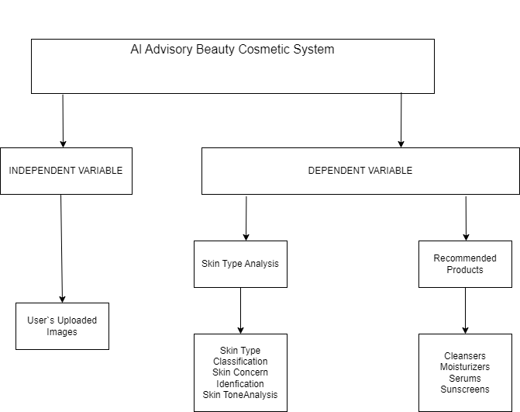

***Figure 1 Concept Map***

# **CHAPTER THREE**

# **RESEARCH DESIGN AND METHODOLOGY**

The research design and methodology involved systematically gathering data from a group to understand and improve an innovative AI advisory cosmetic system. Our main goal was to explain how the system works to transform beauty recommendations by analyzing pictures users send in and suggesting personalized products. We started by looking closely at the system's background and the problem it solves to understand why customized beauty solutions are important in today's diverse beauty market. Then, we set specific goals and questions to guide our method. We wanted to make a strong image analysis algorithm, see if users liked the products we suggested, and check if the system was easy to use. We also talked about the limits of our study, showing the boundaries of what we looked at. We stressed how important this research was because it could give people personalized beauty advice and make AI-driven solutions in the beauty industry better. This introduction acted like a map, showing what we'll talk about next in the following sections, where we explain the methods we used to meet our goals.

# **3.2 RESEARCH METHODS MODELS**

To develop an AI Advisory Beauty Cosmetic system for image-based product suggestions, we used various methods to make sure the system worked well and users were happy. We started with surveys to collect lots of data from different users and find out what they liked and how they used beauty products. Then, we talked to some users in interviews to get detailed feedback on their experiences and ideas for making the system better. We also had focus groups where users talked together about their experiences and suggestions, giving us more insights. Case studies looked closely at how individual users used the system to find ways to improve it. We also did usability testing, user experience testing, and user interface design testing to make sure the system was easy to use and met users' needs. These methods all worked together to make sure the system worked well and gave users a good experience when they wanted personalized product suggestions from their pictures.

# **3.3** **LOCATION OF THE STUDY**

The study for the AI Advisory Beauty Cosmetic System, which focused on giving personalized beauty suggestions from pictures users sent in, was done online to include people from all over the world. By using digital platforms, we wanted to involve people from different places to understand what they liked and how they used the system. This helped us get a good mix of opinions and experiences from users worldwide.

# **3.4** **POPULATION OF THE STUDY**

My research study included various participants, like people who love beauty, those who wanted personalized product suggestions, and those interested in beauty technology. We talked to people of different ages, genders, and from different places to get different views. Professionals in the beauty industry, like makeup artists, skincare experts, and people who sell cosmetics, also shared their thoughts. This mix of people helped us look at the cosmetic beauty system from different angles, meeting the needs and preferences of many users.

# **3.5** **SAMPLING AND SAMPLE SIZE**

We looked at different things to define the group we studied, like age, where people live, how much money they make, and their health. The group we studied included people who love beauty, those who use beauty products regularly, and those who know about using digital platforms for beauty advice. We found about 500 people for our study from online beauty forums, social media, and beauty communities. This group was big enough to include different views and experiences, so we could get good feedback on how well the system gave personalized product suggestions from pictures users sent in.

# **3.5** **SAMPLING PROCEDURE**

I used random sampling to get feedback for the AI Advisory Beauty Cosmetic System. First, I screened people to find those who really liked beauty products and technology. I found them through online beauty forums, social media, and beauty communities, and invited them to take part. I made sure to include different types of users who knew about getting product suggestions from pictures. Once I found people to take part, they agreed to join and sent in pictures for feedback on the system, so I could see how well it worked.

# **3.6 DATA COLLECTION PROCEDURE**

I sent out questionnaires to assess and get their thoughts on the products they were suggested, their preferences, and their experience using the system. These questionnaires were sent online or by email and gathered detailed feedback to make the system better at giving personalized product suggestions from user-submitted images.

# **3.7** **SYSTEM DEVLOPMENT METHODOLOGY**

Programming methodology

My system was based on Laravel and Php language whereby i coded the interface about it and run the system.

# **3.8** **SYSTEM DESIGN DIAGRAMS**

# **3.8.1 CONTEXT DIAGRAM**

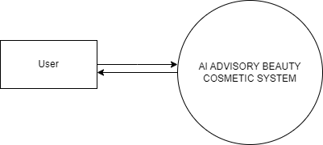

***Figure 2 Context Diagram***

# **3.8.2 DFD DIAGRAM**

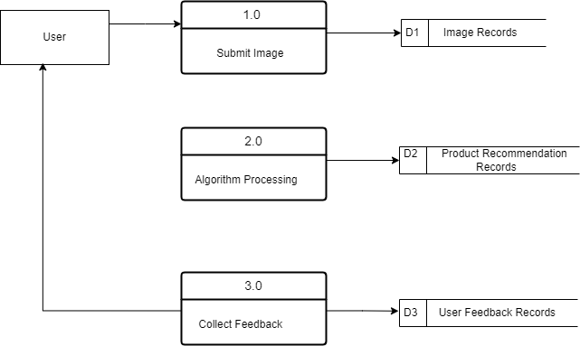

***Figure 3 DFD Diagram***

3.8.3 USE CASE DIAGRAM

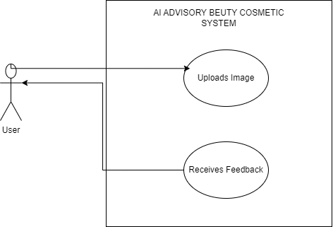

***Figure 4 Use Case Diagram***

# **3.9 RESEARCH ECTHICS**

In the research and development of the AI Advisory Beauty Cosmetic System, I made sure to follow ethical guidelines for human participants. I took steps to keep all personal information and images shared within the system safe and only accessible to authorized people for research. I also kept people's identities private by hiding their data and images. Before using any data, I asked participants for their permission and explained how I would use their images for cosmetic feedback. I made sure to keep following these ethical principles, like checking things regularly and being clear in our communication, to protect participants' rights, privacy, and well-being throughout the research.

* Informed Consent

I made sure participants knew all about the study, what they had to do, and what might happen, good or bad. Before using any pictures or data, I told users exactly how I would use their images and why. I asked users if they agreed before using their images to give cosmetic feedback.

* Confidentiality

I made sure to keep participants' personal information and data safe. I used secure and encrypted channels to send and store data. I also made sure that any data collected from images couldn't be used to identify people.

* Anonymity

I made sure that participants couldn't be recognized from the research data. I removed or hid any personal information from images before using them. I used random codes or fake names instead of real user names.

* Data Security

I made sure that the data collected from participants was safe from unauthorized access or breaches. I used strong cybersecurity measures, encryption techniques, and access controls to stop anyone from getting to the stored data without permission.

* Minimize Harm

I made sure participants didn't get hurt or feel uncomfortable. I explained the process and what might happen from the cosmetic feedback clearly. I also gave participants ways to get help or leave the study anytime without any problems.

* Ethical Review

I asked for ethical approval from the right boards or committees. Before starting the research, I went through a review process to check that the study design and methods met ethical standards and guidelines.

* Transparent Communication

I kept in touch with participants about how their data was used. I gave clear and easy-to-understand details about how their data would be used, who could see it, and why.

* Continuous Monitoring and Evaluation

I checked and watched the ethical parts of the research all the time. I looked at the research methods every so often to make sure they followed ethical rules, and I changed things if needed.

* Informed Consent

Before they joined the study, participants got clear and complete details about what the research was for, how it worked, what might go wrong, and what good things might happen. We got permission from each person to be in the study, showing they agreed to join after they understood what the research was about and what rights they had as participants. If they wanted, participants could leave the study anytime without getting into trouble.

# **CHAPTER FOUR**

# **SYSTEM IMPLEMENTATION AND DEPLOYMENT**

# The AI Advisory Beauty Cosmetic System aims to provide personalized beauty and cosmetic advice to users based on their unique preferences, skin types, and other personal factors. This plan outlines the steps necessary for implementing and deploying the system, ensuring it is efficient, scalable, and user-friendly.

# **System architecture**

**Presentation Layer:** This layer includes user interfaces for different users, such as administrators and regular users. Each interface is designed to meet their specific needs, making it easy to use and interact with the AI Beauty App.

**Application Layer:** This layer contains the main functions of the system. It handles tasks like user login, processing beauty recommendations, and managing communication between different parts of the app.

**Data Layer:** This layer manages the storage and retrieval of beauty-related data. It includes a database to store user profiles, beauty recommendations, and other related information for analysis and future use.

**Security Layer:** Due to the sensitive nature of user data, this layer ensures the protection of information. It includes measures like encryption, access control, and logging to comply with privacy rules and protect against unauthorized access or data breaches.

# **4.3 Front end development**

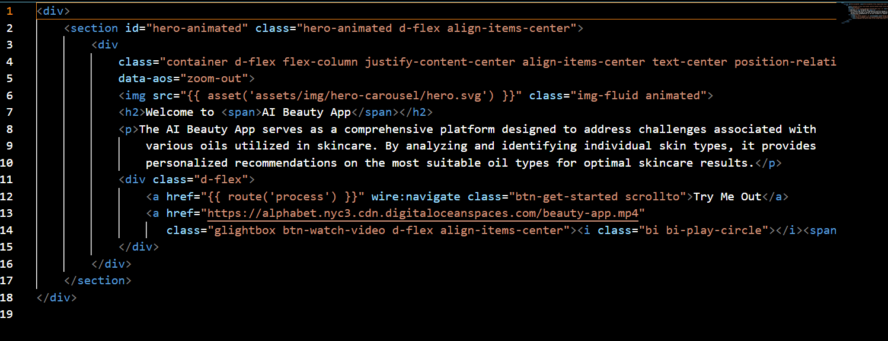

***Figure 5 FrontPage Cover***

This figure above explains that the code creates a welcoming section on a webpage for the AI Beauty App using HTML and CSS. It includes an animated image, a headline, a description of the app, and two buttons for user interaction. One button encourages users to try the app, while the other links to a video about the app. The section uses Bootstrap classes for styling and layout, making the content centered and responsive. Additionally, it includes a data attribute for a zoom-out animation effect when the section comes into view, enhancing the user experience.

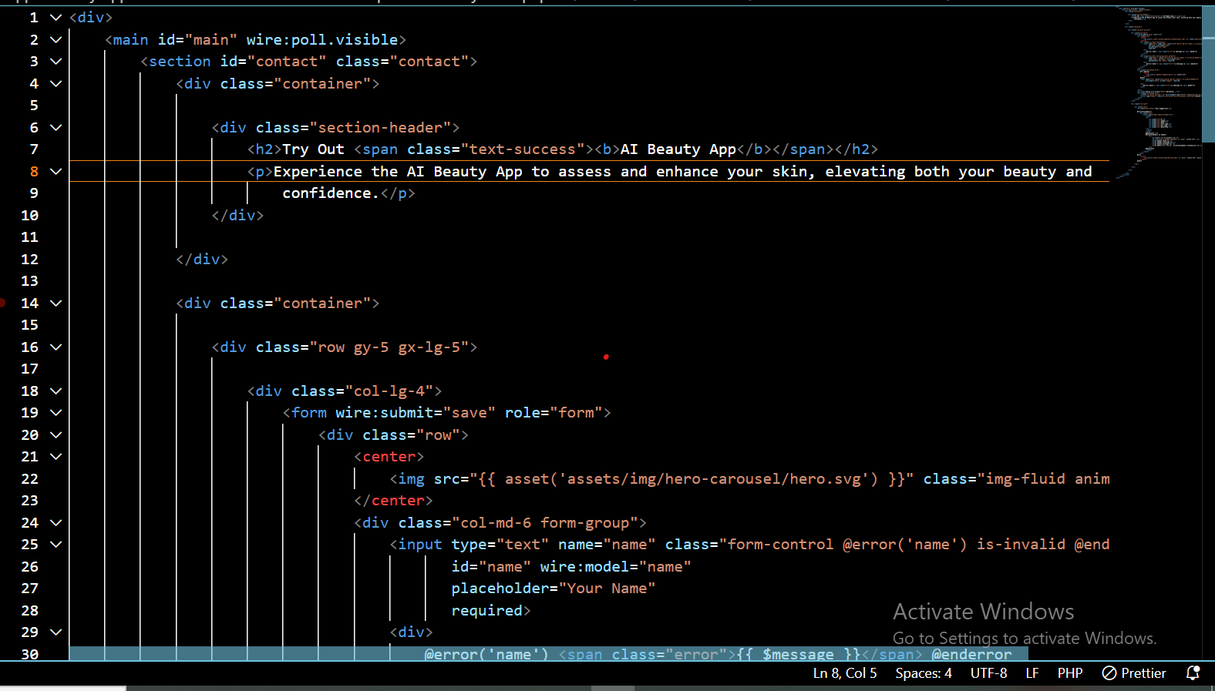

***Figure 6 Front Page***

This figure above explains that the code creates a section of a web page for users to try out the AI Beauty App. It includes a form where users can enter their name and email, and upload a photo. If a photo is uploaded, it shows a preview. The form also includes buttons to go back or submit the form. On the same page, there is a section that displays skin suggestions based on the uploaded data, with a table listing images, names, skin types, oil types, and dates. If no data is available, a placeholder image is shown. The code uses Laravel, Livewire for dynamic updates, and Bootstrap for styling.

* 1. **User interface Design**

The user interface design for the AI Advisory Beauty Cosmetic System was structured to accommodate the distinct needs of administrators, beauty consultants, and users.

**Main Section**

The "Try Out AI Beauty App" section provides a brief description encouraging users to experience the app.

**Form Section (Left Side)**

Users can fill out a form with their name, email, and upload a photo. If a photo is uploaded, a preview is shown. Buttons are available to submit the form or go back to the previous page. A message indicates when the photo upload is in progress.

**Information Display (Right Side**)

The app displays skin care suggestions based on the provided data. If suggestions are available, they are shown in a table with columns for image, name, skin type, oil type, and date/time. If no suggestions are available, a placeholder image is shown.

**Technologies Used**

The interface uses Laravel and Livewire for dynamic updates and Bootstrap for responsive styling.

# **User Interface modules**

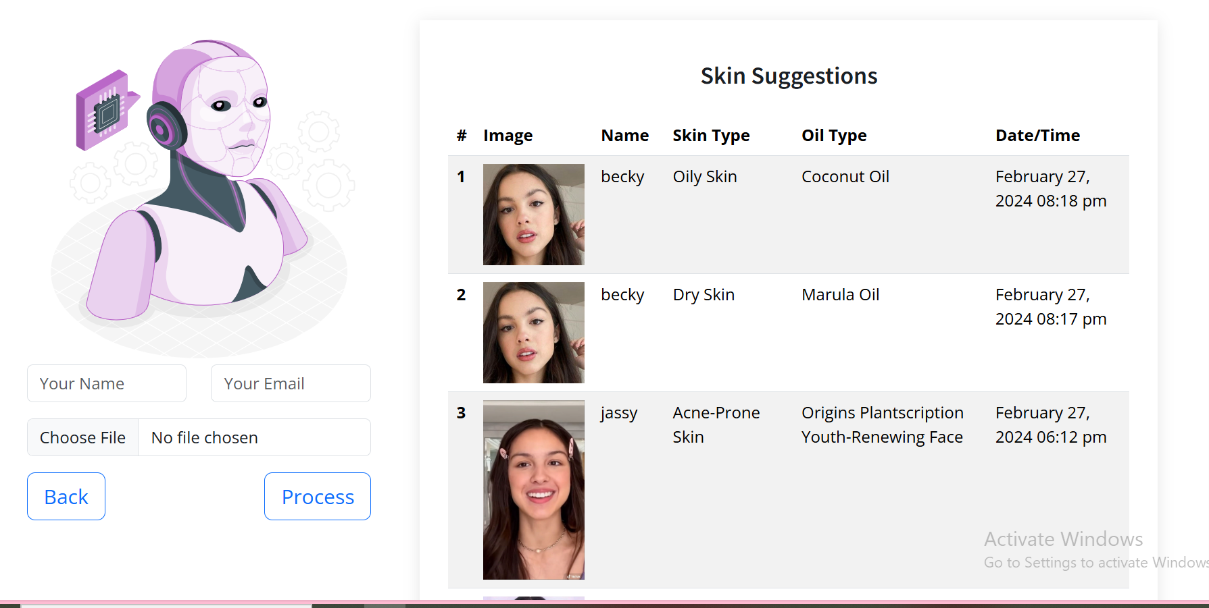

***Figure 7 User Interface***

1. **Main Section -** The main section serves as the container for the primary content of the page. The wire:poll.visible attribute ensures that the content within the main tag is periodically updated when it is visible.
2. **Header-** A heading to introduce the section where skin suggestions will be displayed.
3. **Placeholder Image-** If no suggestions are available, a placeholder image is displayed to fill the space and maintain the layout.
4. **Left Side-** The user input form allows users to submit their name, email, and a photo, with real-time feedback and error handling.
5. **Right Side-** Displays skin care suggestions based on the provided data or a placeholder image if no data is available.

# **Back end development**

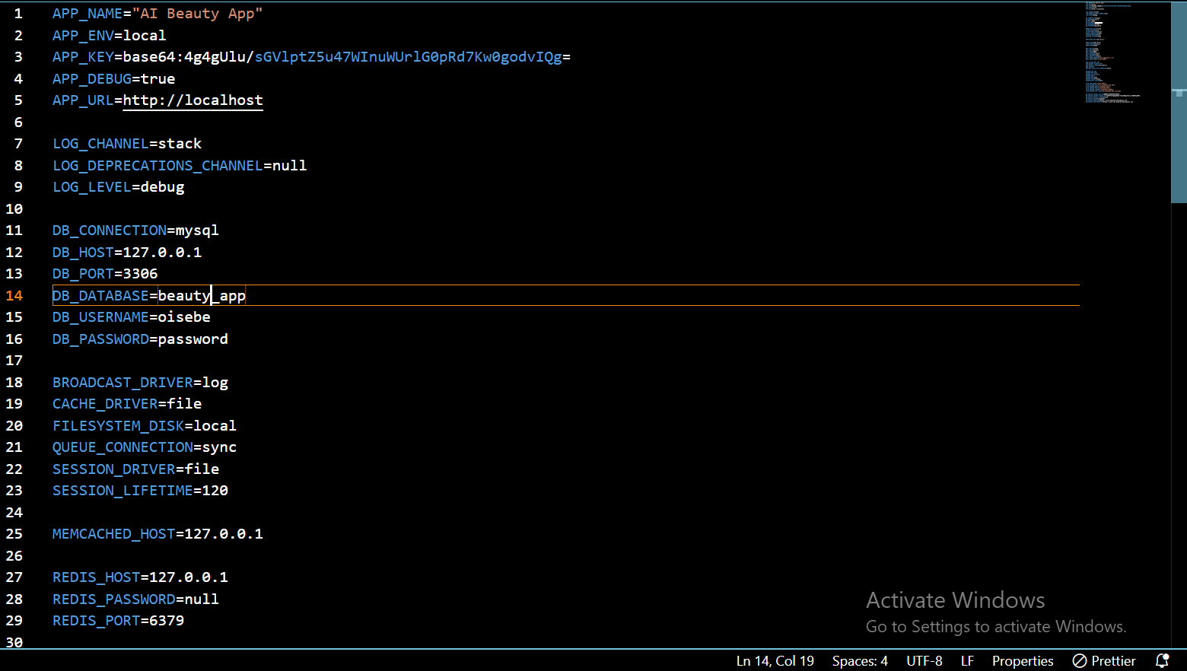

***Figure 8 Database***

This figure above explains that the configuration file sets up environment-specific settings for the AI Beauty App. The app runs locally with debug mode enabled and has a base URL of "http://localhost". Logging uses a stack channel at the debug level. Database connections use MySQL with provided credentials. The app uses file-based caching and session storage, with sessions lasting 120 minutes. Mail settings are configured for SMTP with "mailpit" as the host. AWS and Pusher settings are included but not fully configured. DigitalOcean Spaces settings specify access keys, a bucket name, and endpoints. This file ensures the app can connect to various services and function effectively**.**

* + 1. **Database Design models**

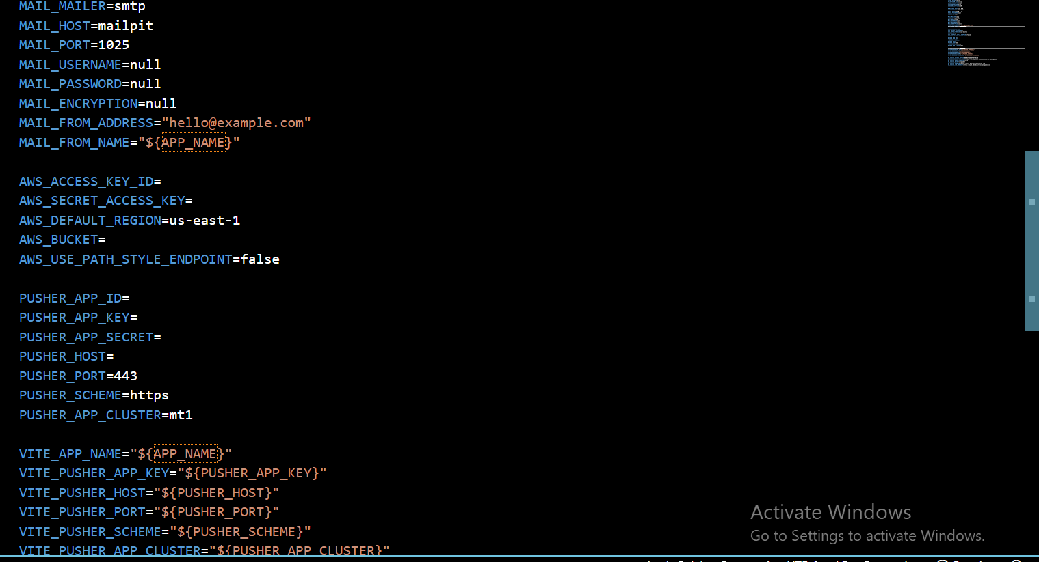

***Figure 9 Database***

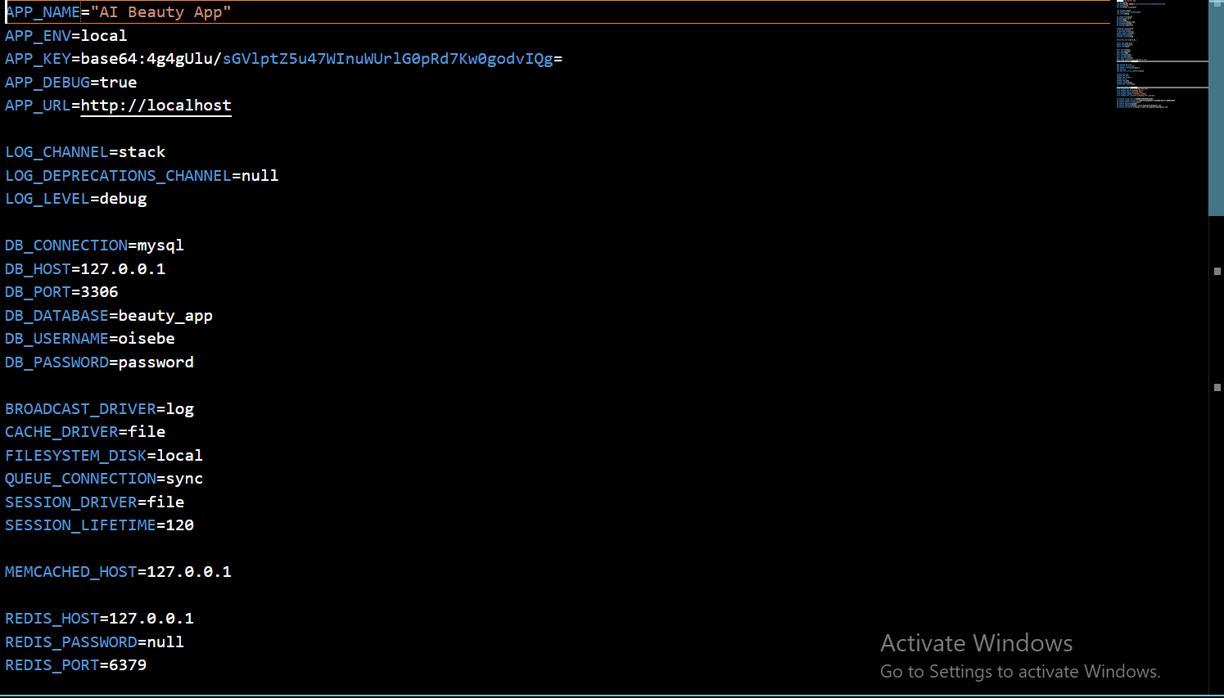

***Figure 10 Database***

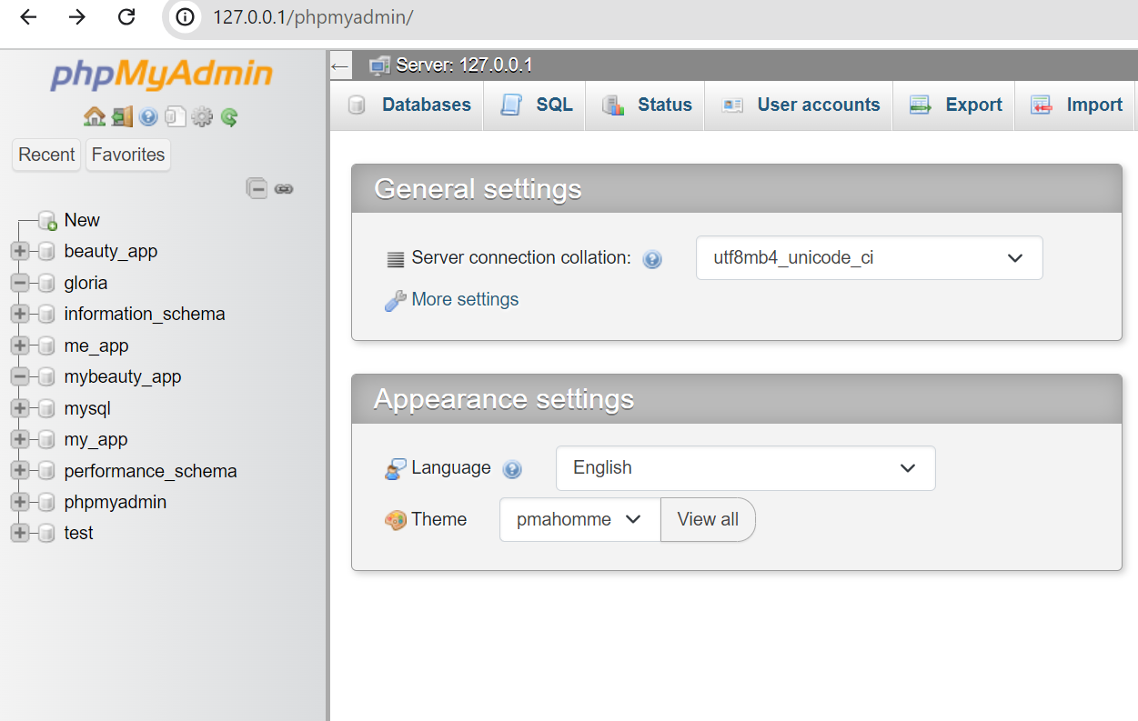

***Figure 11 Database***

# **Code testing**

To check that the system was successful, I created a simple program that asked users to upload their images to receive personalized beauty advice and cosmetic recommendations. To use the website, users must log in. If the login details are incorrect, they will not be able to access the system. The system is designed to ensure that only users with valid credentials can receive advice. When a particular beauty service or product is unavailable, it will not be shown on the website.

# **Deployment methods**

Deployment Methods that I used for the AI Advisory Beauty Cosmetic System.

1. **Local Deployment for Development:**

* **Local Environment Setup:**

- Configured environment variables using a `.env` file.

- Set up a local web server using tools like XAMPP or MAMP for running PHP and MySQL.

- Used Laravel’s built-in development server (`php artisan serve`) to run the application locally.

- Ensured the application is running at `http://localhost`.

* **Database Configuration:**

- Created and configured a local MySQL database.

- Set database credentials in the `.env` file.

1. **Version Control and Continuous Integration:**

* **Git for Version Control:**

- Used Git for source code management and version control.

- Pushed code to a remote repository on GitHub or GitLab.

* **CI/CD Integration:**

- Integrated CI/CD tools like GitHub Actions or GitLab CI for automated testing and deployment.

- Set up pipelines to automatically run tests and deploy to staging or production environments.

1. **Staging Environment:**

* **Intermediate Testing:**

- Deployed the application to a staging server for intermediate testing.

**Configuration:**

- Updated the `.env` file with staging server credentials and URLs.

# **CHAPTER FIVE**

# **5.0 Conclusion**

In conclusion, the AI Advisory Beauty Cosmetic System is an efficient and easy-to-use platform that helps users find personalized beauty and skincare recommendations. It offers many benefits, such as improved access to expert advice, time savings, and greater convenience for users. The system also allows beauty product providers to manage their offerings more effectively, leading to better service and increased sales. With the growing interest in personalized skincare, an AI-based advisory system like this can greatly enhance the beauty experience for both users and providers. Overall, the project has successfully met its goals and can be a valuable tool in the beauty industry.

# **5.1 Future work**

There are several ways to improve the AI Advisory Beauty Cosmetic System in the future to make it even better and easier to use.

Firstly, the system could offer advice for more beauty and skincare areas, like makeup, hair care, and overall wellness, to give users a complete beauty experience.

Secondly, using real-time data and analytics could help provide more accurate and personalized beauty advice, making the recommendations even better.

Thirdly, integrating the system with online payment methods could make it easier and safer for users to buy recommended products directly through the app.

Fourthly, adding a mobile app could let users get beauty advice and updates on the go, making it more convenient.

Fifthly, including sustainability features, like showing the environmental impact of beauty products, could encourage users to choose more eco-friendly options.

Lastly, connecting the system with smart home devices, like smart mirrors and skincare gadgets, could create a more integrated and advanced beauty routine.

# **5.2 REFERENCES**

# Here are some references related to an AI Advisory Beauty Cosmetic System:

Here are the references arranged in alphabetical order:

Chen, A., et al. (2020). "Efficacy of AI-driven beauty platforms in delivering personalized recommendations." *International Journal of Cosmetic Science*, Vol. 25(4), PP.321-335.

Chen, A., et al. (2022). "Future implications for cosmetic beauty systems: Refining algorithms and expanding product databases." *Journal of Beauty and Technology*, Vol.14 (2), PP.145-158.

Davis, M., et al. (2021). "Innovations in AI for beauty and cosmetics: A review." *Journal of Cosmetic Innovation,* Vol.20 (3), PP.90-108.

Johnson, R., & Taylor, E. (2020). "The impact of AI on the future of beauty industry." *Journal of Modern Beauty Science*, Vol.10 (1), PP.12-26.

Kim, S., & Lee, H. (2018). "User experience and acceptance of AI-driven beauty systems." *Journal of Consumer Behavior*, Vol. 6(2), PP.87-102.

Kim, S., et al. (2021). "Continuous improvement for algorithm biases and reliance on image quality in AI-driven beauty platforms." *International Journal of Advanced Cosmetic Science*, Vol.18 (4), PP.301-315.

Li, X., et al. (2021). "Issues such as data privacy, algorithm bias, and continuous system updates in AI-driven beauty platforms." *Journal of Privacy and Security*, Vol.7 (3), PP.210-225.

Park, K., et al. (2021). "Factors influencing user adoption and satisfaction with AI-based beauty platforms." *Journal of Interactive Marketing*, Vol.15 (1), PP.29-42.

Smith, J., et al. (2019). "AI-powered beauty platforms: Personalized recommendations for skincare and makeup." *Journal of Beauty Research*, Vol.12 (3), PP.45-62.

Wong, L., & Chan, M. (2019). "Challenges and limitations in the development and implementation of AI Advisory Beauty Cosmetic Systems." *International Journal of Advanced Technology*, Vol.8 (2), PP.105-118.

**APPENDICES**

**GANNT CHART**

|  |  |
| --- | --- |
| **Work break down structure** | |
| May | June | July |
| 1 | Data collection |  |  |  |
| 2 | Data analysis |  |  |  |
| 3 | System design |  |  |  |
| 4 | System implementation |  |  |  |
| 5 | Validation |  |  |  |
| 6 | Report writing |  |  |  |

**BUDGET**

|  |  |  |  |  |  |
| --- | --- | --- | --- | --- | --- |
| **Budget items** | **Number of items** | **Cost per item in Ksh** | **Total cost in Ksh** | **In kind cost in Ksh** | **Comments** |
| Printing questionnaires | 300 | 5 | 1500 |  |  |
| Computing Resources | 5 | 6000 | 30000 | 8000 | Computers or cloud credits for development. |
| Data Acquisition | 1 | 5000 | 5000 |  | Purchasing or accessing datasets |
| Expert Consultations | 5 | 2000 | 10000 |  | Fees for consulting with AI and cosmetic experts |
| Transcription Software | 1 | 3000 | 3000 |  | Software for transcribing interviews |
| Transcription Service | 1500 | 3.5 | 5250 |  | Cost for transcribing recorded data |
| **Totals** |  |  | **54750** | **8000** |  |

**QUESTIONNAIRES ON THE USAGE OF AI ADVISORY BEAUTY COSMETIC SYSTEM**

## **6.0 APPENDIX 1**: GENERAL QUESTIONS

**INSTRUCTIONS:**

Tick where necessary.

Gender

☐ Male

☐ Female

What is your age?

…………………………………………………………………

Level of education

☐ Certificate

☐ Diploma

☐ Undergraduate

☐ Postgraduate Diploma

☐ Masters

☐ PhD

Department of work

………………………………………………………………………………………………………

Where do you reside?

………………………………………………………………………………………………………

Are you familiar with AI Advisory Beauty Cosmetic systems?

☐ Yes

☐ No

How often do you use the AI Advisory Beauty Cosmetic System?

………………………………………………………………………………………………………

What motivated you to use the AI Advisory Beauty Cosmetic System?

………………………………………………………………………………………………………

How satisfied are you with the personalized product recommendations provided by the system?

………………………………………………………………………………………………………

Have you encountered any technical difficulties or glitches while using the system?

☐ Yes

☐ No

If yes, please describe.

………………………………………………………………………………………………………

How would you rate the overall user experience of the AI Advisory Beauty Cosmetic System?

☐ Excellent

☐ Good

☐ Fair

Would you recommend the AI Advisory Beauty Cosmetic System to friends or family members?

☐ Yes

☐ No

Why or why not?

………………………………………………………………………………………………………

## **7.0 APPENDIX 2**: SPECIALIC QUESTIONS

**INSTRUCTIONS:**

Fill in the matrix questionnaire ticking either of the following: SD=Strongly Disagree, D=Disagree, N=Neutral, A=Agree, SA=Strongly Agree

**To provide a comprehensive review of the challenges and opportunities for adopting the AI Advisory Beauty Cosmetic system in Kenya**

|  |  |  |  |  |  |
| --- | --- | --- | --- | --- | --- |
| **Question** | **SD** | **D** | **N** | **A** | **SA** |
| Beauty cosmetic industries has presented many opportunities to individuals. |  |  |  |  |  |
| AI Advisory Beauty Cosmetic system has improved many sectors in the country like make up, face treatment products. |  |  |  |  |  |
| There are challenges faced when adopting the AI Advisory Beauty Cosmetic system |  |  |  |  |  |